Testi Vitali

HOMEPAGE:

**The magazine**:

Founded in 2022, The Observer for Justice is a monthly magazine that reports about forms of iniquity and violence which victimize social communities all over the world. Our motto is ‘**Fight injustice trough information’** and we decide to devote our first release to 20 years of chronic police abuse: from the **27th G8 summit**, held in **Genoa** in 2001, marked by violent clashes between anti-globalization protesters and police, to the "**Black Lives Matter**" movement, boomed after the **murder of George Floyd** and other episodes of racial hatred perpetuated by white officer.

**The Issue**

In the ‘Issue’ section, you will find three selected insights on the topic. The first one is a detailed and unvarnished chronicle of what happened during those painful days of Genoa, due to which the European Court of Human Rights found Italy guilty of **torture**. The second is a recent analysis on data about racial bias and police brutality in United States. The last insight is a scientific article that highlight how intense and numerically significant are the contacts between police and people suffering from mental disorders.

**The Project**

The project is the result of the course ‘Information Modelling and Web Technology’ held by Professor Fabio Vitali of the University of Bologna, in the academic year 2020-2021. One of the main aims is to explore the different styling teste, from the past and the future. Thanks to the style timeline, in the Filter section of the navbar, the user can access to this first number of the magazine switching from a very basic and contemporary style to one inspired by the Dada movement of 1920 and to 70’s style, shaped on the famous “Topolino” comic book (“Mickey Mouse” in English).

**ABOUT**

**The Project**

*The Observatory for Justice* is a project realized for the examination of the course of [**Information modelling and web technologies**](https://www.unibo.it/it/didattica/insegnamenti/insegnamento/2019/424627) held by Fabio Vitali within the [**Master Degree in Digital Humanities and Digital Knowledge**](https://corsi.unibo.it/2cycle/DigitalHumanitiesKnowledge) of the University of Bologna. According to the guideline, the purpose of the website is to display three articles dealing with the same theme/main topic. The scopes of the site are displaying articles through different styles and layouts which should be influenced by real typographic movements, achievable through a cross-analysis of textual metadata.

The designer

I graduated in February 2020 in Humanities (Modern Curriculum) at Federico II in Naples with a thesis in Romance Philology. I’m currently attending “Digital Humanities and Digital Knowledge” (LM-43 Master degree) at the Alma Mater Studiorum University in Bologna. I am a huge fan of photography: after studying and practicing digital photography (and postproduction in Photoshop) for years, I have also extended my knowledge to analogic photography. The image-based modelling, the 3d modelling and the graphic design represent fields of knowledge that I would have a sincere pleasure to deepen.

1920 STYLE

To reconstruct the 1920 historical style, I decide to take inspiration from the Dadaism movements and their styles. Developed in reaction to World War I, Dadaism is one of the most unconventional and Avante-Garde art and cultural movements of recent history, born in Zürich, Switzerland, at the Cabaret Voltaire (c. 1916) and lasted until the mid 1920s. Dadaism was a very eclectic movement that explored a range of non-traditional materials, nonsensical content and satire. Beyond typically artistic media, Dada artists also investigated performance art and literature. In their magazine and manifestos, they experimented with liberating the written word from institutional conventions.

The movement reached various European and American cultural centers: among the most famous were the German, the Parisian and the New Yorker ones. They share aspects, but they also differ a lot. This is why choosing just one main reference magazine seemed to me the only chance to obtain a realistic dada style, faithful to the original example.

THE REFERENCE MAGAZINE:

The International Dada Archive (<https://dada.lib.uiowa.edu/>), a scholarly resource for the study of the historic Dada movement, has been a precious support to reconstruct the Dadaist panorama and its testimonies. Going through its catalogue of periodicals, I found the Berlin-based **Der DADA**, a magazine edited by Raoul Hausmann, John Heartfield and George Grosz. It had only three releases: the first published in June 1919, the second in December 1919 and the third and last in April 1920.

[carrellata di immagini]

It seemed to me full of details and interesting graphic cues, perfectly suitable to the digital format of a web page. Initially, I was undecided whether to use Der Dada or **Dada** magazine, born in Zurich in 1917 from the idea of Tristan Tzara, its editor, and in operation until 1920, when its head-quarter moved to Paris. Finally, the coherence of some visual aspect (as the quite homogeneous background color of the sheets of paper), harmoniously merged with graphic distortions, in Der Dada persuaded me. Anyway, I also replicated some stylistic features of DADA magazine and other official publications. The style of “The Designer”, at the end of the homepage, want to be a direct replica of the title of Dadaglobe solicitation form letter signed by Francis Picabia, Tristan Tzara, Georges Ribemont-Dessaignes, and Walter Serner, in November 1920.

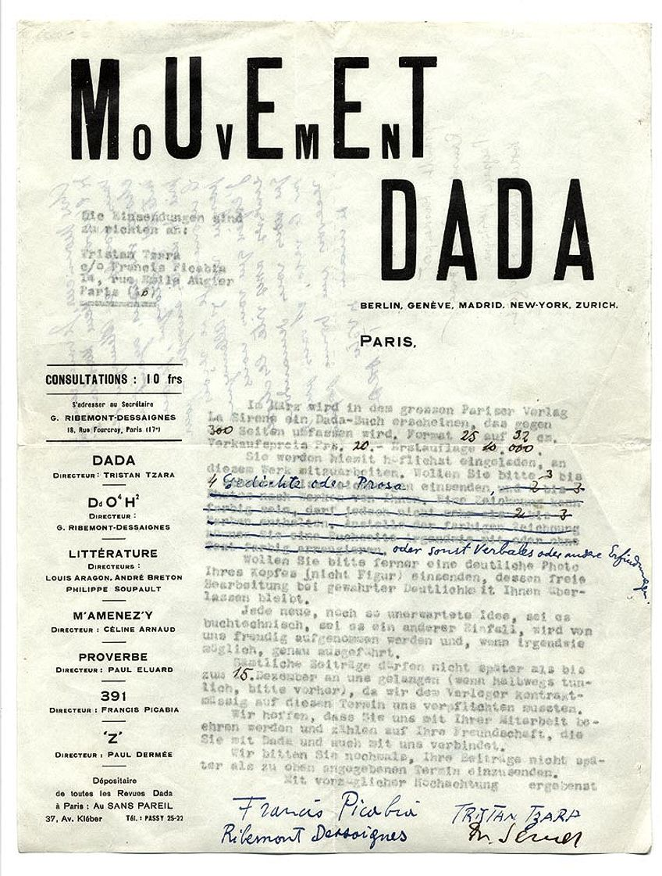

Thus, I decided to follow Raoul Hausmann’s trail also to design the <b>**cover image</b>** of the homepage, substitutive of the video footage, published by Rai and visible in the opening section of the website.

The collage was inspired by his work “<b>**ABCD</b>**” (1923-1924), described by The Centre Pompidou of Paris, in this way:

“This photomontage – a technique Raoul Hausmann started using in 1918 – exploits the many possibilities of collage. ABCD is a demonstration of the artist’s mastery of the art, the figures, objects, letters and numbers all being tightly integrated. The first four letters of the alphabet appear in the artist’s open mouth, adding a **sense of sound** to the purely visual, a sense supported by the scattered letters that form the word “VOCE”, voice. This produces a kind of still of a film with sound in which everything takes place at once.”

I tried to replicate this sense of sound, quite significant compared to the silence to which George Flyod was force by white officer Derek Chauvin and to the scream of revenge “No Justice, No Peace” that resounded in the streets during the subsequent demonstrations.

Thanks to PhotoScapeX and remove.bg (<https://www.remove.bg/>), I cut out and put together pieces of photos and excerpts from newspapers, portraying the protests in Genoa during G8 Summit in 2001 and the ones broke out in USA during the summer of 2020. Finally, I overlaid the collage with some light effects in order to obtain an old-fashioned flavour. This is the result.

For what concerns the icon in the navbar to switch to Dada style, I opted for the *Fountain,* (New York, 1917) Duchamp’s first experiment with readymade and one among the more recognizable symbols of the movement. I took a picture of the object and working with contrast value, I extracted the silhouette of the urinal. Below the result.

For the cursor, instead, […]

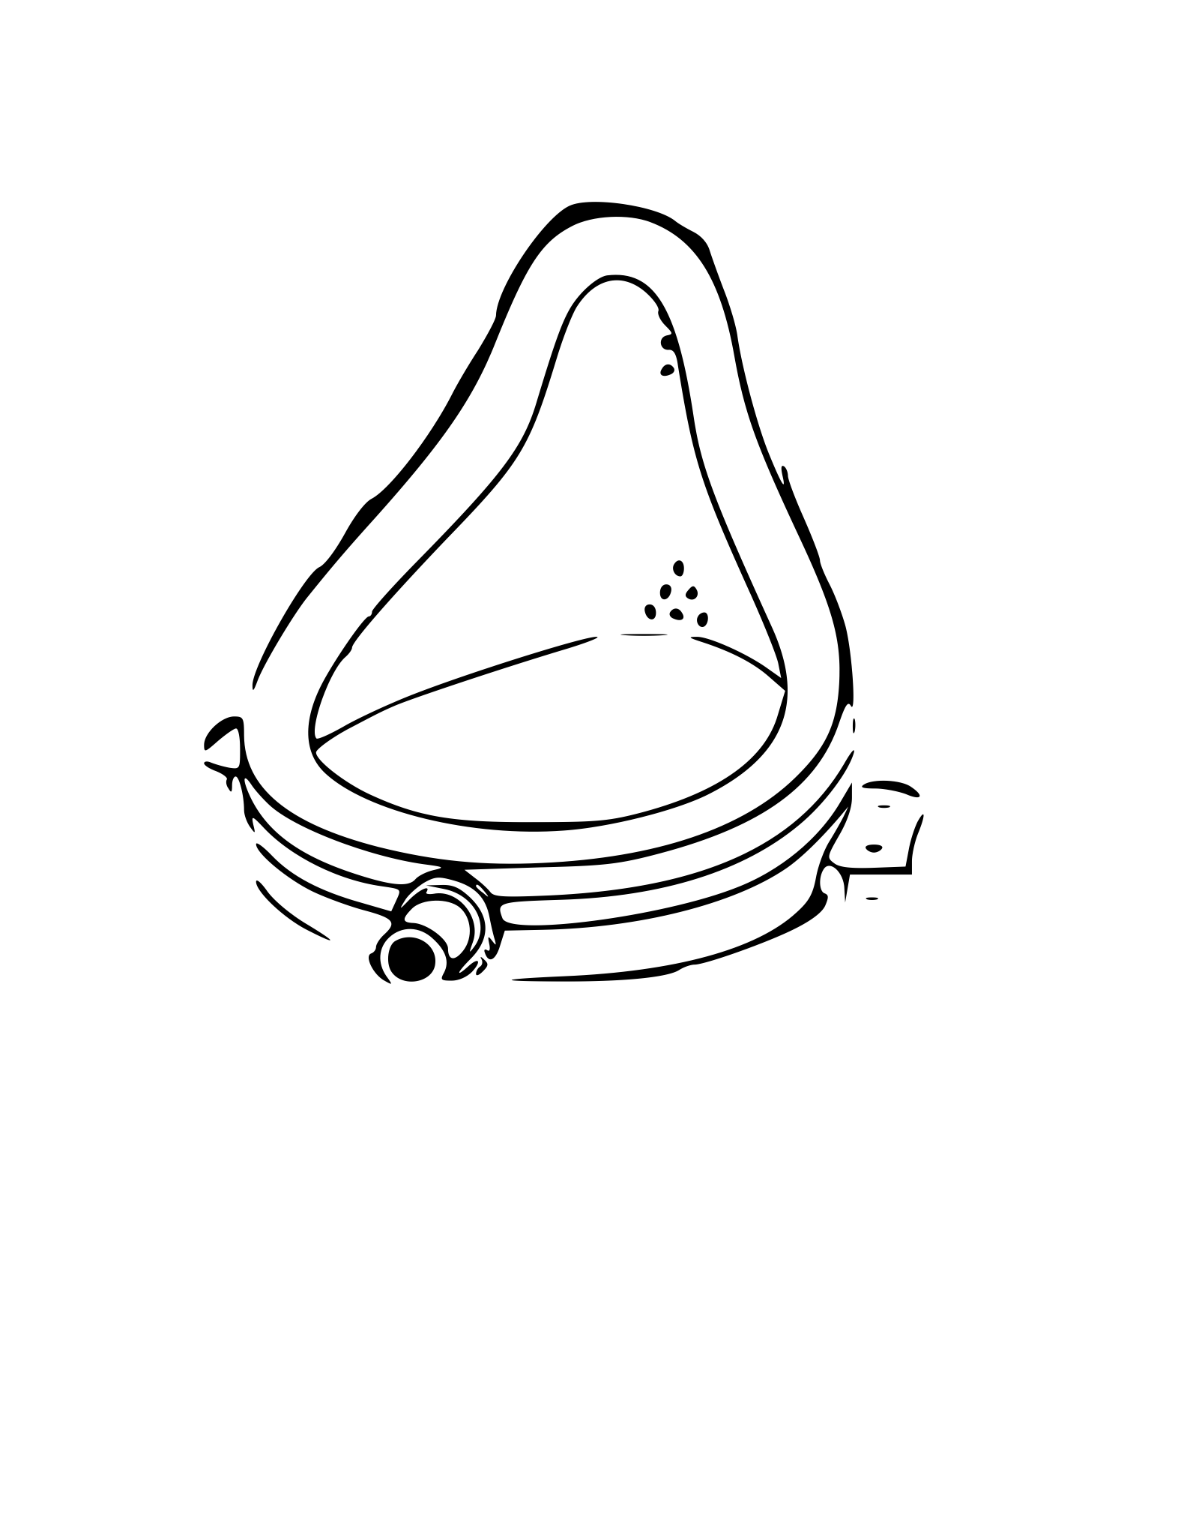

Unconventional

FONTS

I mixed several fonts, in order to hold the variety of typographic styles that coexisted in Dada newspapers. I played especially with the headers and titles. Some opensource softwares, such as <a href=” https://www.whatfontis.com/”>Whatthefont</a> and <a href=” [https://www.myfonts.com/”>My](https://www.myfonts.com/)Fonts</a> , have been very helpful to match the exact fonts of some pieces of text extracted by Der Dada pages. Anyway, lots of results produced by their algorithms lead to paid packages. I settled on a compromise between high resemblance and free downloadable options.

LAYOUT

COLORS

1970 STYLE

The 1970s were filled with many social movements and cultural trends that greatly influenced graphic design. The psychedelic hippy, disco and punk movements are probably the first thing that comes to mind when you think of the groovy ‘70s. Anyway, there was also a less flamboyant substratum of visual manifestations that reflects the change of air, without losing their trademark.

During that decades an entire generation of youngs

THE REFERENCE MAGAZINE

FONTS

LAYOUT

COLORS

At the moment of publication, the magazine contains four issues. Each issue is made up of four articles selected by an individual member of the **editorial team** and concerning a specific area of scientific investigation. Issues are presented inside a visualizer page, which allows the possibility of navigating across the number, switching typographic styles and examining **meaningful information** from a metadata viewer, both for the single article and the related publication. Issues are represented in a tripartite form. They include: a cover page, that works as a table of content/index giving access to the documents, the corpus of the issue made of articles and a back-cover, used as a disclaimer page specifying the scope and purpose of the site and the copyright of the documents. Each article is enriched with **metadata** that refer to its editorial history, its source and the related content information, such as meaningful occurrences of people, places, dates, concepts, credits and entities. Information are meant to be related, in order to create a complex network of references across articles of the same issue.

Historical theming is meant to give us a general overview of the evolution of layout design and typography styles **across the centuries**, from the handwritten manuscript form to the automatic reading of the future. Each layout has been studied to capture the use of characters, margins, spaces, colors, pagination and new media visualization. More detailed information about design choices can be found in the [documentation](https://theyemagazine.github.io/documentation.html) of the project.

**Me**

Documentation:

Markup

Dada Style

(The reference magazine, Fonts, Layout, Colors)

Topolino ’70 Style

(The reference magazine, Fonts, Layout, Colors)

If you love food, this is your place.

Here at the Daily Meal magazine we are three food lovers who share a passion for cooking...and eating! Explore the history, the cultural differences, and the sustainability, health and global warming aspects regarding three of the most delicious and internationalized food in the world. Go to the second page to find out more about our [tasty issues](https://the-daily-meal.github.io/index.html).

The Daily Meal is **not just a simple magazine** about food. Thanks to our **style timeline**, the user can travel through time, discovering the layout differences, typography changes and tendencies among different historical periods. Explore our [documentation](https://the-daily-meal.github.io/index.html) to see in detail our design choices!

Finally, the **metadata viewer** in our issues section enable the user to overview the relevant data and metadata and scroll to the relevant part of each article. The metadata is issue-specific, article-specific and fragment-specific. The user is able also to access the items through a reverse search: clicking on a name in the text scrolls the table to show all the instances of the same name. Take a look and enjoy the reading!

The Eye Magazine selects the most interesting articles already present on the net on the most varied scientifical topics and, as an aggregator, collects them in periodic issues of four articles each. All the issues are united by their strong adherence to the time we are living, while distinguishing themselves for the more specific topics covered by the articles: until now we can include in our selected library items related to technology, climate change, space and health. And many more are coming!

The magazine takes care to cite the source and to provide access to the original pieces, but enhances the already valuable scope of these articles through the inclusion of tools for viewing the information and metadata contained therein. You will thus be able to easily and efficiently access information about and within the text, living your reading as a completely new experience.

From an aesthetic point of view, also, The Eye Magazine does not give up on surprising. In fact, you will be able to change the aspect of the article you are reading, choosing from over a thousand years of styles inspired by historical layouts. Browse the site, choose the item that interests you most and try to change its graphics. Then, read them in a completely new way. Ready to get started?

The Project

The project is the result of the course ‘Information Modelling and Web Technology’ held by Professor Fabio Vitali of the University of Bologna, in the academic year 2020-2021.

. Our main aim was to explore the different ways people form the past (and the future) styled texts, approaching this as an expression of the taste of that period. Together with the interest in graphic design, there is the research of a new, modern way to read texts offered by the power of contemporary technology. Thanks to its means and tools indeed, The Eye Magazine provides its users with ways to access information referred to and contained in the gathered texts, enhancing their knowledge with internal and external links to them. Want to know more? Access our About section and look at all the detailed information about our project.